Community Service Log

Name of establishment | Date | Total Hours | Description

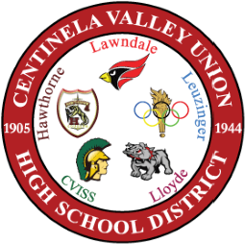

Centinela Valley Union High School District

